1. Summarize chapters 2 in the text book.

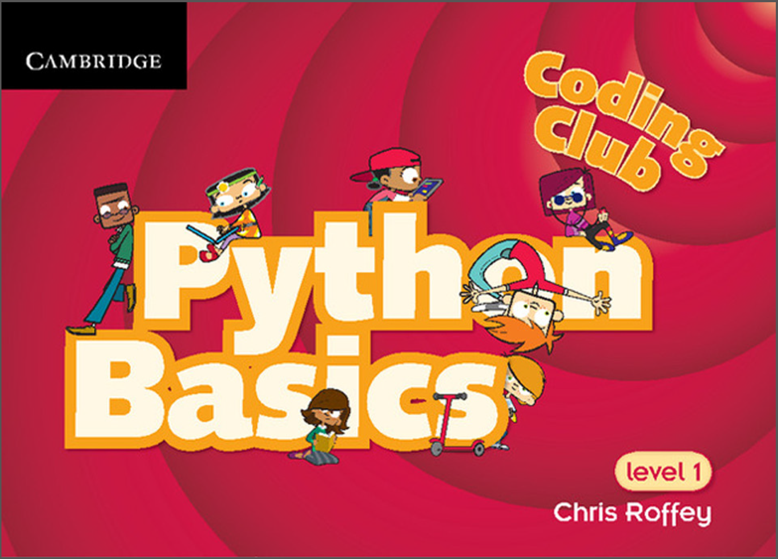

1. Install the Python based on the P_L_02_Fin.pptx file.
2. Submit your screen with the installed Microsoft Visual Studio Community 2019.